NED UNIVERSITY OF ENGINEERING & TECHNOLOGY, KARACHI


DEPARTMENT:
COMPUTER SCIENCE & INFORMATION TECHNOLOGY

CT-175 PROGRAMMING FUNDAMENTALS
COMPLEX COMPUTING PROBLEM (CCP) REPORT

PROJECT NAME:
WEEKLY HEALTH TRACKER & ADVISOR

SUBMITTED TO:
MISS AMNA

SUBMITTED BY:
MUHAMMAD SAAD BIN KHALID (CT-25245) (GROUP LEAD)
ABDULLAH BIN WAQAR (CT-25246)
HASSAAN AHMED KHAN (CT-25248)
MUHAMMAD SHIBLEE SHAMIM (CT-25233)
MUHAMMAD MUJEEB REHMAN (CT-24200)

Introduction & Scope:
The Weekly Health Tracker & Advisor is an interactive console-based and web-based application designed to help students track their weekly health. The program collects input on daily water intake, sleep hours, and hours workout from user, calculates averages, and provides advice based on their report.
Our project revolves around the fundamental programming concepts of arrays, loops, functions, pointers, and conditional statements. The project's modular design, along with core logical reason and structured programming, enhances the overall efficiency.
Scope:
- Record daily water intake, sleep, and workout for a week.
- Calculate weekly averages and give health advice.
- Display summary in console and UI using charts via Streamlit.
- Give advice based on tracking

Block Diagram of Functions & Methodology:

Complete Source Code:
C Pragram:

#include <stdio.h>

#define DAYS 7 // constant

void inputData(float water[], float sleep[], float workout[]);
void calculateAverages(float water[], float sleep[], float workout[],
float *avgWater, float *avgSleep, float *avgWorkout);
void getAdvice(float avgWater, float avgSleep, float avgWorkout);
void displaySummary(float water[], float sleep[], float workout[],
float avgWater, float avgSleep, float avgWorkout);
void mainMenu(float water[], float sleep[], float workout[]);

// ** Main Function **

int main() {
float water[DAYS], sleep[DAYS], workout[DAYS];
mainMenu(water, sleep, workout);
return 0;
}

// ** Main Menu **

void mainMenu(float water[], float sleep[], float workout[]) {
int choice;
float avgWater = 0, avgSleep = 0, avgWorkout = 0;
printf("\n\nWelcome to Weekly Health Tracker & Advisor!\n\n");
do {
printf("\n--- Main Menu ---\n");
printf("1. Enter/Update Weekly Data\n");
printf("2. View Summary & Advice\n");
printf("3. Exit Program\n");
printf("Enter your choice (1-3): ");
scanf("%d", &choice);

switch (choice) {
case 1:
inputData(water, sleep, workout);
calculateAverages(water, sleep, workout, &avgWater, &avgSleep,
&avgWorkout);
printf("\n--- Data Input Completed! ---\n");
printf("Select option 2 to view the results.\n");
break;

case 2:
if (avgWater == 0 && avgSleep == 0 && avgWorkout == 0) {
printf("\nNo data found. Please select option 1 first.\n");
} else {
displaySummary(water, sleep, workout, avgWater, avgSleep, avgWorkout);
getAdvice(avgWater, avgSleep, avgWorkout);
}
break;

case 3:
printf("\nProgram Exited successfully!\n");
break;

default:
printf("\nInvalid choice. Please enter 1, 2, or 3.\n");
break;
}
} while(choice != 3);
}

// ** Take inputs **

void inputData(float water[], float sleep[], float workout[]) {
int i;
printf("\nEnter your water intake per day (in litres): \n");
for (i = 0; i < DAYS; i++) {
printf("\nEnter water intake Day %d: ", i + 1);
scanf("%f", &water[i]);
if (water[i] < 0) {
printf("Water intake cannot be negative!\n");
i--;
continue;
}
}

printf("\nEnter hours you sleep per day (in hrs): \n");
for (i = 0; i < DAYS; i++) {
printf("\nEnter sleep Day %d: ", i + 1);
scanf("%f", &sleep[i]);
if (sleep[i] < 0 || sleep[i] > 24) {
printf("\n\nEnter hours within 0-24!!");
i--;
continue;
}
}

printf("\nEnter your workout time (in hours): \n");
for (i = 0; i < DAYS; i++) {
printf("\nEnter workout duration Day %d: ", i + 1);
scanf("%f", &workout[i]);
if (workout[i] < 0 || workout[i] > 24) {
printf("\n\nEnter hours within 0-24!!");
i--;
continue;
}
}
}

// ** Calculates averages **

void calculateAverages(float water[], float sleep[], float workout[],
float *avgWater, float *avgSleep, float *avgWorkout) {
float sumWater = 0, sumSleep = 0, sumWorkout = 0;
int i;
for (i = 0; i < DAYS; i++) {
sumWater += water[i];
sumSleep += sleep[i];
sumWorkout += workout[i];
}
*avgWater = sumWater / DAYS;
*avgSleep = sumSleep / DAYS;
*avgWorkout = sumWorkout / DAYS;
}

// ** Display weekly summary **
void displaySummary(float water[], float sleep[], float workout[],
float avgWater, float avgSleep, float avgWorkout) {
int i;
printf("\nDays\t\tWater (L/day)\tSleep (hrs/day)\tWorkout (hrs/day)");
for (i = 0; i < DAYS; i++) {
printf("\nDay %d:\t\t%.2f\t\t%.2f\t\t%.2f", i + 1, water[i], sleep[i],
workout[i]);
}
printf("\n\nAverage:\t\t%.2f\t\t%.2f\t\t%.2f", avgWater, avgSleep,
avgWorkout);
}

// ** Displays Advice **
void getAdvice(float avgWater, float avgSleep, float avgWorkout) {
printf("\n\n\t\t\t\tHealth Advice");
if (avgWater < 2.0)
printf("\nIncrease your daily water intake to around 2 liters per day.");
else
printf("\nYour water intake is good!");

if (avgSleep < 8.0)
printf("\nTry to get at least 8 hours of sleep daily.");
else
printf("\nYour sleep hours are sufficient!");

if (avgWorkout < 0.5)
printf("\nIncrease workout time to at least 30 minutes per day.");
else
printf("\nYour workout routine is good!");
printf("\n");
}

Streamlit (Python) Code:
import streamlit as st
import pandas as pd

if "water" not in st.session_state:
st.session_state.water = [0.0] * 7
st.session_state.sleep = [0.0] * 7
st.session_state.workout = [0.0] * 7

st.set_page_config(page_title="Weekly Health Tracker", layout="wide")
st.title("🌿 Weekly Health Tracker & Advisor")

# Sidebar menu
menu = ["Enter/Update Weekly Data", "View Summary & Advice"]
choice = st.sidebar.selectbox("Menu", menu)

# Functions
def calculate_averages():
avg_water = sum(st.session_state.water) / 7
avg_sleep = sum(st.session_state.sleep) / 7
avg_workout = sum(st.session_state.workout) / 7
return avg_water, avg_sleep, avg_workout

def get_advice(avg_water, avg_sleep, avg_workout):
advice = []
if avg_water < 2.0:
advice.append("💧 Increase daily water intake to ~2 liters/day.")
else:
advice.append("💧 Water intake is good!")

if avg_sleep < 8.0:
advice.append("🛌 Try to get at least 8 hours of sleep daily.")
else:
advice.append("🛌 Sleep hours are sufficient!")

if avg_workout < 0.5:
advice.append("🏋️ Increase workout to at least 30 minutes/day.")
else:
advice.append("🏋️ Workout routine is good!")
return advice

def progress_bar(value, goal, label):
pct = min(value / goal, 1.0)
if pct < 0.5:
color = "🔴"
elif pct < 1.0:
color = "🟡"
else:
color = "🟢"
st.progress(pct)
st.write(f"{label}: {value:.2f} / {goal} {color}")

def has_data():
return any(v > 0 for v in st.session_state.water + st.session_state.sleep + st.session_state.workout)

# Option 1: Enter/Update Data
if choice == "Enter/Update Weekly Data":
st.header("📝 Enter Your Weekly Data")
for i in range(7):
st.subheader(f"Day {i+1}")
st.session_state.water[i] = st.number_input(
f"Water intake (L)", min_value=0.0, value=st.session_state.water[i], step=0.1, key=f"water{i}"
)
st.session_state.sleep[i] = st.number_input(
f"Sleep hours", min_value=0.0, max_value=24.0, value=st.session_state.sleep[i], step=0.5, key=f"sleep{i}"
)
st.session_state.workout[i] = st.number_input(
f"Workout hours", min_value=0.0, max_value=24.0, value=st.session_state.workout[i], step=0.25, key=f"workout{i}"
)
st.success("✅ Weekly data updated!")

# Option 2: View Summary & Advice
elif choice == "View Summary & Advice":
if not has_data():
st.warning("⚠️ No data found. Please enter your weekly data first!")
else:
st.header("📊 Weekly Summary")
data = {
"Water (L/day)": st.session_state.water,
"Sleep (hrs/day)": st.session_state.sleep,
"Workout (hrs/day)": st.session_state.workout
}
df = pd.DataFrame(data, index=[f"Day {i+1}" for i in range(7)])
st.table(df)

# Calculate averages
avg_water, avg_sleep, avg_workout = calculate_averages()
st.subheader("📈 Averages")
col1, col2, col3 = st.columns(3)
with col1:
progress_bar(avg_water, 2.0, "Water")
with col2:
progress_bar(avg_sleep, 8.0, "Sleep")
with col3:
progress_bar(avg_workout, 0.5, "Workout")

# Display advice
st.subheader("💡 Health Advice")
advice = get_advice(avg_water, avg_sleep, avg_workout)
for a in advice:
st.write(a)

# Weekly trends chart
st.subheader("📊 Weekly Trends")
st.line_chart(df)

Sample Output:
C Program (Console):

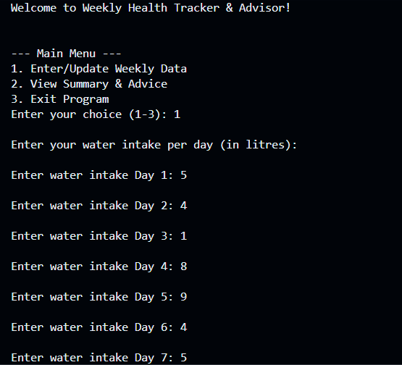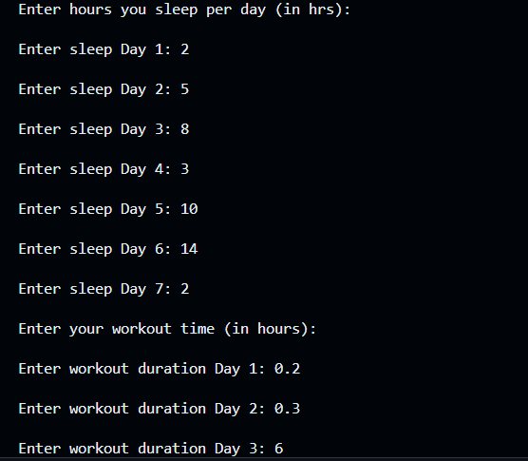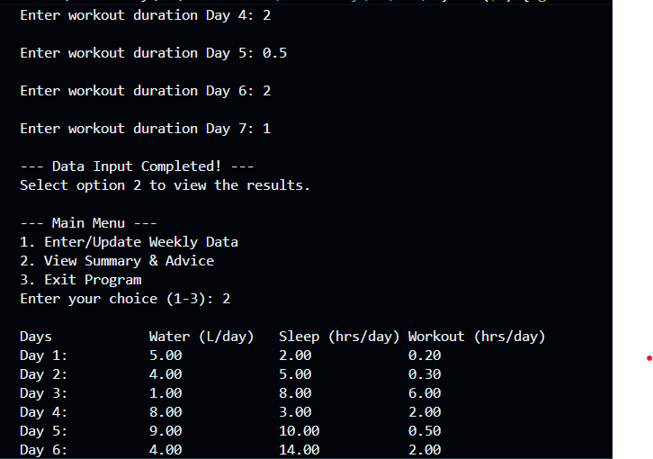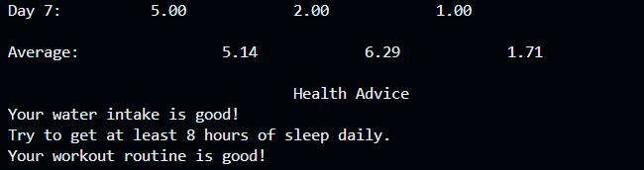

Streamlit UI (Web Interface):
The streamlit output is presented as Graphical UI.

Future Add-Ons & Limitations:
Future Add-Ons:
- File storage to save weekly logs
- Track multi-week health progress
- Export weekly reports as PDF

Limitations:
- No long-term memory or history tracking
- Does not perform advanced calculations like sleep score, health rating scale, weekly trend detection

